Getting started with the HealthCare Journey image sharing and viewing system

- Register your free account using the Chrome browser https://radconnect.com/account/healthcarejourney

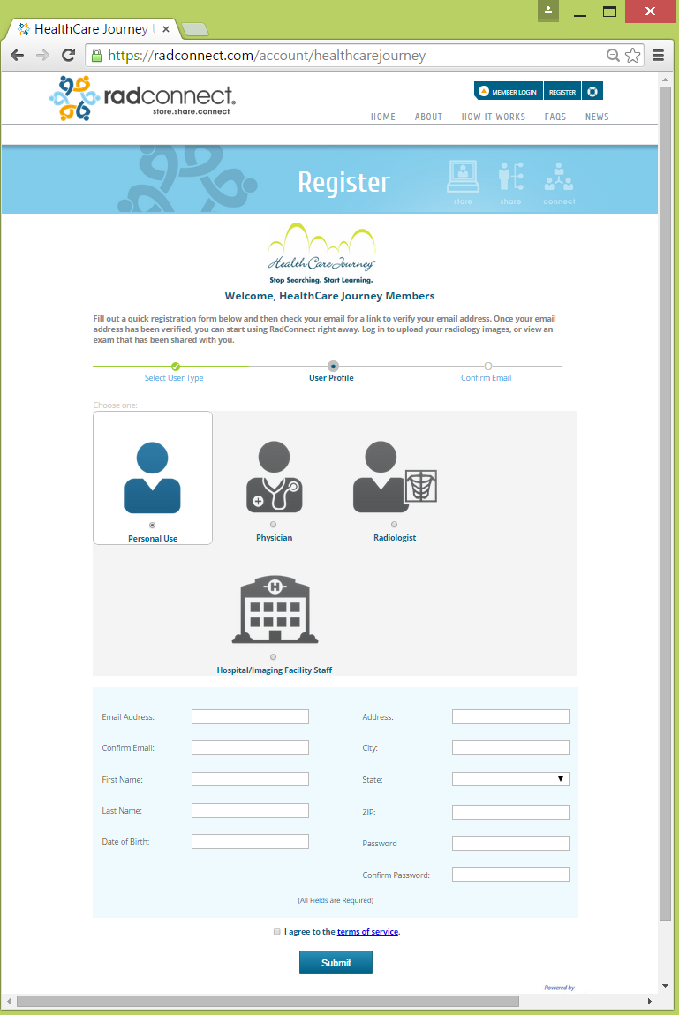

- Upload your medical images from you CD, hard drive, or thumb drive
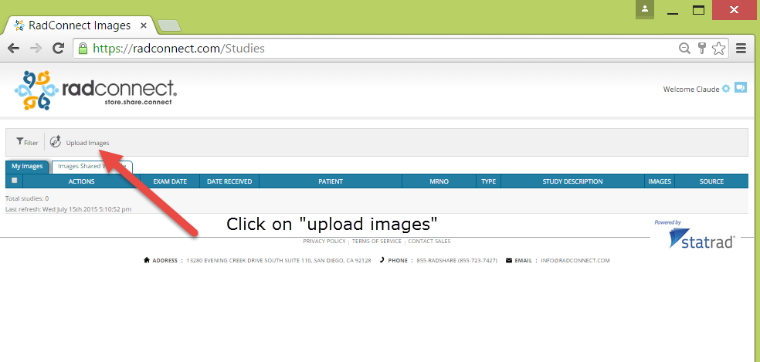
- View your images

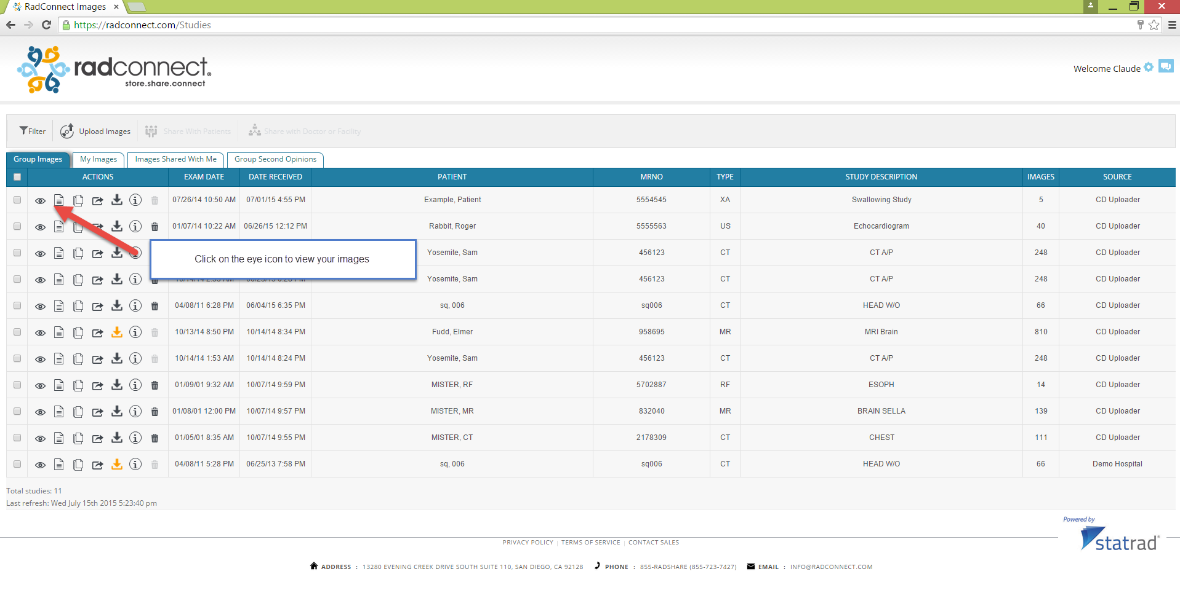
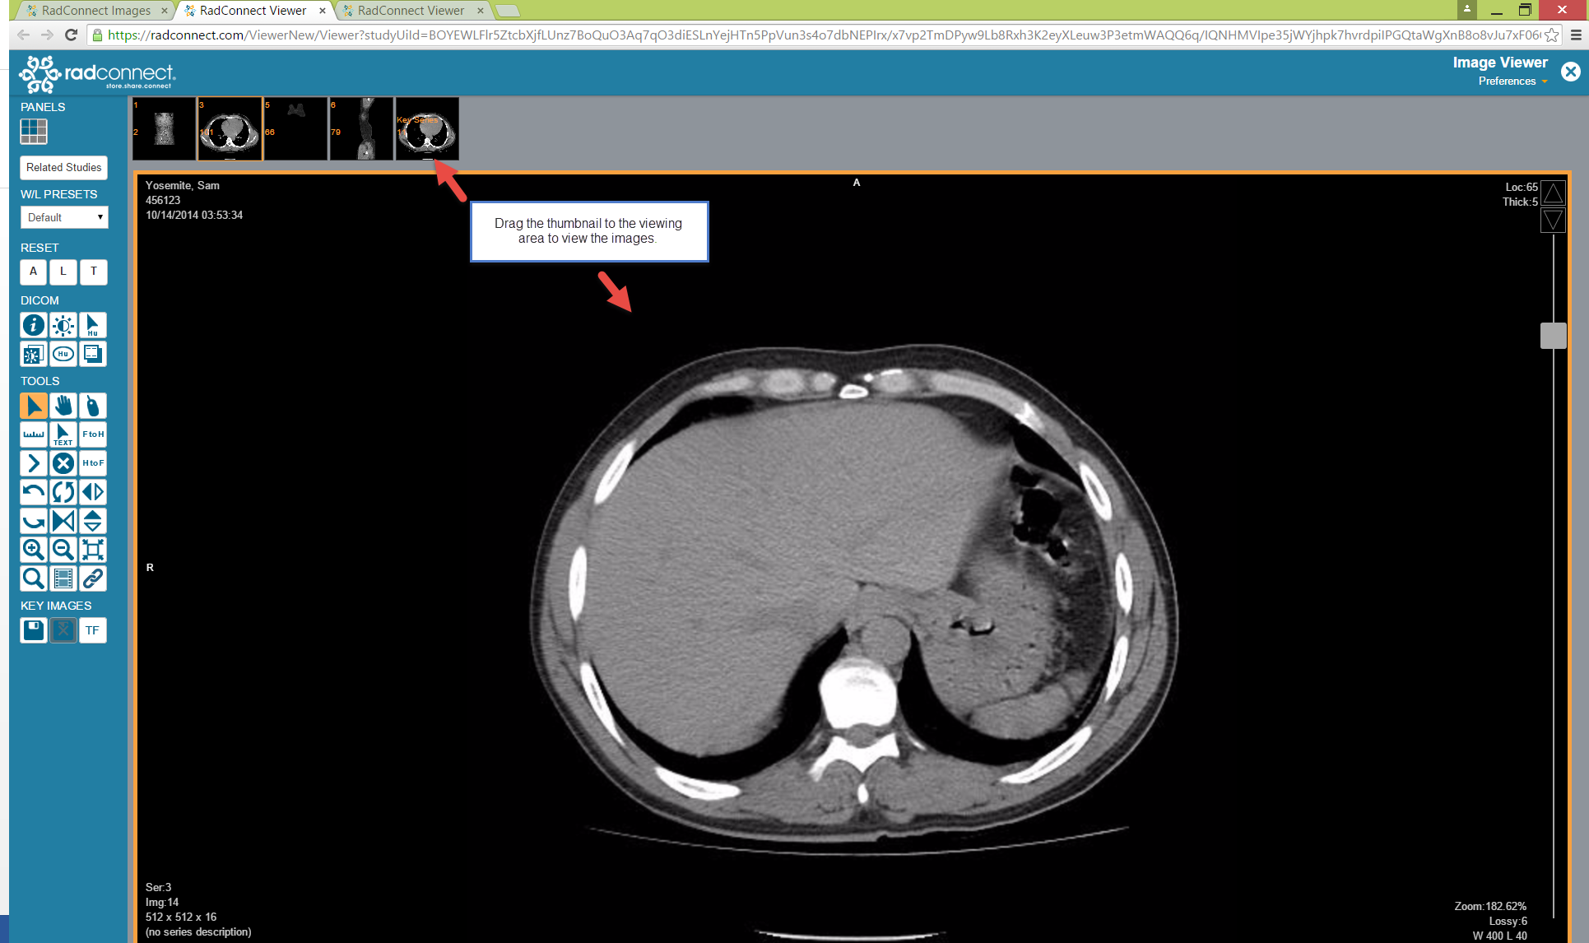

When you are finished, just close the browser or click on RadConnect logo in the upper left hand of your screen to get back to the worklist. Once you close your browser, everything is in the cloud so your information is safe and secure.

For a tutorial, please click here:

Viewing images:
https://www.google.com/webhp?sourceid=chrome-instant&ion=1&espv=2&ie=UTF-8#q=radconnect%20video

Sharing images:
https://www.youtube.com/watch?v=MCOTdk0q5YQ

